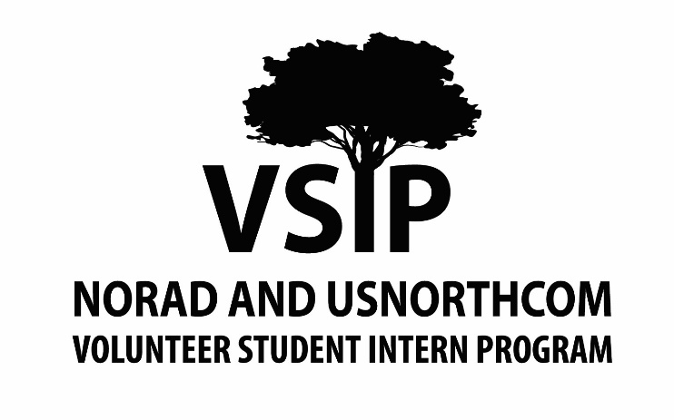

|  |  |
| --- | --- |
| Disclosures | |
| I understand, Under *5 U.S.C. 3111*, a student volunteer is not a Federal Employee for any purposes other than injury compensation and law related to the *Tort Claims Act*. Student participation in the program occurs on a voluntary basis, and there is no remuneration, or other employee benefits provided. NORAD and USNORTHCOM do not provide housing assistance or support. Volunteer service is not credible for leave or any other employee benefits or monetary compensation. | |
| Signature | Date |
| I understand, all NORAD and USNORTHCOM Volunteer Student Internship Program candidates must consent to a suitability determination, a security investigation, and drug testing protocols. Acceptance into the program is conditional upon favorable completion of these requirements. | |
| Signature | Date |
| I understand, if accepted into the NORAD and USNORTHCOM Volunteer Student Internship Program that I will be expected to work no less than 20 hours a week but no more than 40 hours per week, or a minimum of 4 days per week. | |
| Signature | Date |
| I understand that any materials provided during the application, suitability determination, and security investigation may be shared between members of the NORAD and USNORTHCOM Volunteer Student Internship Program Administration and the appropriate Security Managers. All communication between such parties is confidential and encrypted to protect the applicant and NORAD and USNORTHCOM | |
| Signature | Date |

|  |  |  |  |
| --- | --- | --- | --- |
| Personal Information | | | |
| Prefix (Ms. / Mrs. / Mr. / Mx. / Dr.) | Name (Last, First MI) | | |
| Permanent Mailing Address | City | State | Zip |
| Phone | Email | | |

|  |  |  |
| --- | --- | --- |
| Education | | |
| Academic Institution | | GPA |
| Degree Program | Expected Graduation Date (DD MMM YY) | |
| Major(s) | Minor(s) | |
| Academic Institution | | GPA |
| Degree Program | Dates of Attendance (DD MMM YY) | |
| Major(s) | Minor(s) | |

|  |  |
| --- | --- |
| Work Experience | |
| Employer | Job Title |
| Dates of Employment (DD MMM YY) | Supervisor |
| Supervisor Phone | Supervisor Email |
| Military Experience  Never Served  Active Duty  Reserves  Veteran  Other (Please Explain): | |

|  |  |
| --- | --- |
| Security Clearance | |
| Have you ever held a security clearance?  Yes  No | |
| Clearance Level  Secret  TS  TS/SCI | Dates of Activity (MMDDYYYY) |
| Issuing Organization | |

|  |  |  |  |  |
| --- | --- | --- | --- | --- |
| Language Proficiency | | | | |
| Please use <https://www.govtilr.org/index.htm> to rate your proficiency, on a scale of 0-5, for all languages with which you have professional, academic or personal experience.   1. No or Memorized Proficiency 2. Elementary Proficiency 3. Limited Working Proficiency 4. General Professional Proficiency 5. Advanced Professional Proficiency 6. Functionally Native Proficiency | | | | |
| Language | Reading | Writing | Listening | Speaking |
|  |  |  |  |  |
|  |  |  |  |  |
|  |  |  |  |  |
|  |  |  |  |  |
|  |  |  |  |  |

|  |
| --- |
| Position |
| Rank your top 5 areas of interested in NORAD and USNORTHCOM J-Directorates and Special Staff Offices, with 1 being the most and 5 being the least.    ___ N&NC/J1 Manpower and Personnel  ___ N&NC/J2 Intelligence  ___ N/J3 Operations  ___ NC/J3 Operations    ___ N&NC/J4 Logistics and Operations  ___ N&NC/J5 Strategy, Policy and Plans  ___ N&NC/J6 Cyberspace Operations  ___ N&NC/J7 Joint Training and Exercises  ___ N&NC/J8 Requirements, Analysis and Resources  ___ Washington Operations Center  ___ Special Staff |
| Application Term (Spring / Summer / Fall) |
| How did you hear about the NORAD and USNORTHCOM Volunteer Student Internship Program? |
| Are you applying to other internships for the same term you are applying to the NORAD and USNORTHCOM Volunteer Student Internship Program? |

|  |  |
| --- | --- |
| Acknowledgement | |
| My statements on this form an in any attachments are true, complete and correct to the best of my knowledge. I understand that falsification of my answers in this form or any attachment will lead to the rejection of my application and immediate dismissal from the program. | |
| Signature | Date |
| Short Answer Questions | |
| Please answer each of the following questions in no more than 250 words. A response is required for each question. | |

|  |
| --- |
| Why are you interested in participating in the NORAD and USNORTHCOM Volunteer Student Internship Program |
|  |

|  |
| --- |
| What skills, characteristics or talents do you possess that sets you apart? |
|  |

|  |
| --- |
| Describe your professional goals, and how your extra-curricular activities support these goals. |
|  |

|  |
| --- |
| Describe your role model, and how they have influenced your professional goals and aspirations. |
|  |

|  |
| --- |
| Describe which current NORAD and USNORTHCOM missions do you value most, and why. |
|  |

|  |
| --- |
| Describe a time that you faced adversity in a professional setting, and how you overcame the situation. |
|  |